

Plan & Billing

Help Center

Log Out

Whenever user clicks on this dropdown arrow

the above options should show up as well as the name of our partnered finance institution should show up in above manner.

For example, Samasta Microfinance in this case.

* Also, whenever the user clicks on above options and their sub-pages, we must provide user a route to return back on this front application page.
* I believe this can be done by placing CredQ logo header in each page of above option and their sub-pages.

**APPLICATION LEFT 2000**

**START**

**NEW APPLICATION**

Note:

* Need an API Integration platform for users.
* Need Web & Mobile Optimized Platform for users.
* ‘Start New Application’ tab will should get inactive once the user exhausted all application (Application Left tab) and should redirect to payment.
* Post your questions regarding ‘Payment Gateway’ in our WhatsApp group. Also, In the billing section, provide all the possible payment method for user like debit card, credit card, Paytm, PhonePe, Rupay etc. Net Banking?
  + Let’s aim to finish this part by 10th Mar’2021 or earlier.
  + I will provide you with *‘Start New Application’* tab wireframes once you’re done with this part.
  + Let me know if you have some better idea to improve and make it better.

**Plan & Billing**

Change your plan, update your billing info, and download your invoices

**CredQ**- **Essentials Plan**

Application Needed

0/2000

Total Amount

(I agree to CredQ’s Terms & Conditions) – Keep this below ‘Pay Now’

As of now in the backend, you can keep the cost

of 1 application = INR 7.99

Enter the number of applications needed

INR 15980

**Pay Now**

**Your Payment Details**

Name on card

Kushagra Mishra

Card information

MasterCard ending in 1799

Name or company name

Kushagra Mishra

Address

1200 West Creek Village Drive, Apt-D2

Postal code, city, country

21921, Elkton, US

Delete Info

Change Info

When user clicks on **Change Info** , below screen should show-up:

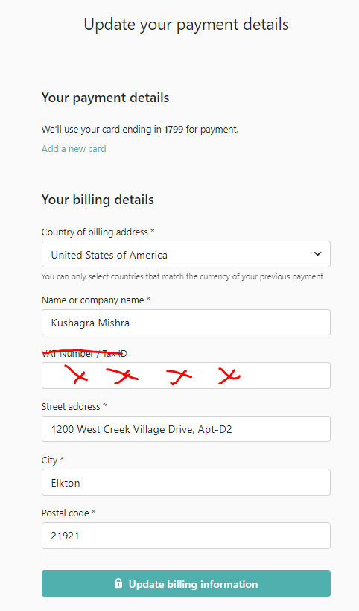

* When user clicks on **‘Add a new card’** below screen should show up:

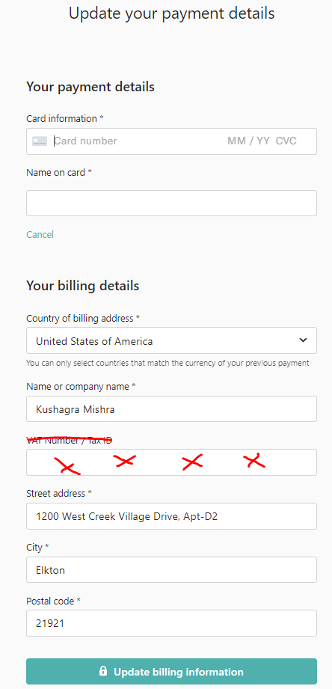

When user clicks on **Delete Info** , below screen should show-up

Are you sure you want to delete your billing information?



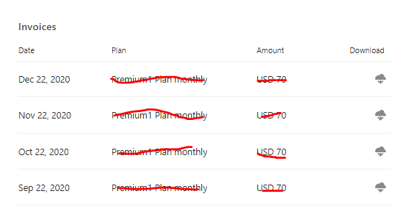

* Plan = Essentials, Amount = INR 15980

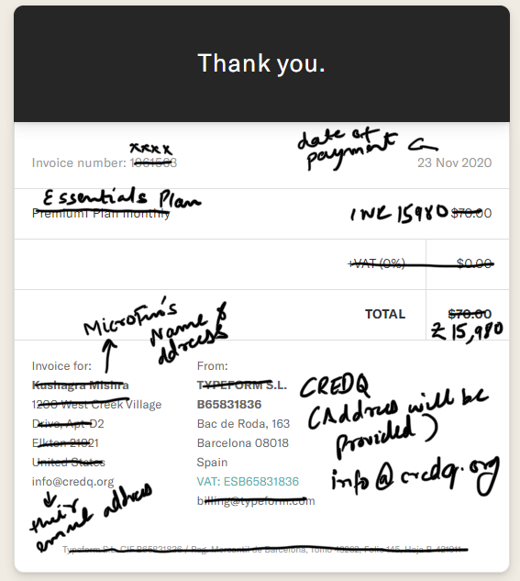

I guess - In order to reflect the details in downloaded invoice, you can pull the information from **‘Billing address & Schedule a Demo’** of the user from backend.

**Request to upgrade the plan**

When user clicks on it, a following message should show up: “Your request has been sent. One of our team member will contact you shortly”.

To Summarize the “Plan & Billing Section”, the following (2) screens and (1) tab should show up to user, whenever he/she clicks on it:

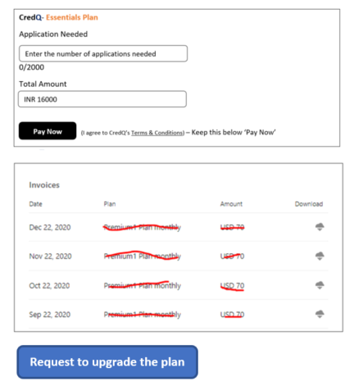

**Help Center**

Can we insert link to our WhatsApp Number here?

Something like below: - Whenever a user click on Help Center, user should see below chat tab:

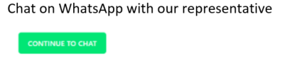

**Logout**

Redirect to the ‘Partner Login’ Page